NLP_Reading
Question:
Can human-based attention enhance LLM's performance and make them more similar to the human brain?
- By constraining LLMs' attention weights with human cognition-grounded attention, such as eye movements, and comparing their performance in downstream tasks like reasoning with that of naive LLMs, we can assess whether this approach improves LLMs' understanding of language.
- Does an LLM fine-tuned eye movement data resemble the human brain more when processing words? To explore this, we will compare activations in different layers of both fine-tuned and naive LLMs with activations in various brain regions at different time points.
Motivation:
LLMs excel in natural language tasks but rely solely on statistical relationships learned from large text corpora, lacking true language understanding. In contrast, humans dynamically adjust their attention to different parts of a text based on the need for real-time word integration into context. This dynamic attention is reflected in eye movement patterns during reading comprehension.
If we equip LLMs with human eye movements—an attention index grounded in actual language understanding—can they achieve a deeper understanding of language and perform better in complex tasks such as reasoning? Moreover, if they do improve, is this enhancement due to a greater similarity between LLMs and the human brain?
(Another point: Do more advanced LLMs, such as DeepSeek, outperform others because they more closely resemble the brain?)
Uniqueness:
So far, most studies at the intersection of cognitive neuroscience and NLP focus on speech comprehension tasks, where the brain passively receives auditory input as speech unfolds. This setup limits the brain’s flexibility in adjusting attention during language comprehension. In contrast, reading imposes no such constraints, allowing for a full exploration of the brain’s dynamic attention shifts during language processing. This provides more valuable insights into how humans allocate attention when processing language.
Additionally, our extensive dataset of co-registered brain recordings (MEG) and eye movement data precisely aligns brain activity with eye movement patterns for each word during reading. This multimodal, multidimensional dataset is unique and offers rich insights into the neural mechanisms underlying language processing.
(another point: Furthermore, in reading, linguistic information is conveyed visually, naturally integrating visual and linguistic processing. This creates a unique opportunity to investigate the intersection of computer vision and NLP.)
Experimental paradigm:
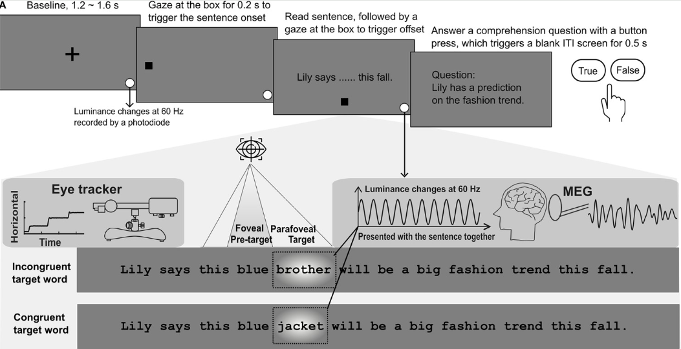
- Task: natural reading
Read one-line sentences, and occasionally answer comprehension questions (~20% of the sentences)
(The luminance change of target words, known as frequency tagging, is used to measure covert attention allocated to the target word and can be disregarded here.)
- 217 Participants:
right-handed English native speakers, aged 18-35, with normal or corrected-to-normal vision and no neurological or reading disorders.
- 54380 Sentences:
one-line with ~10 words (no more than 81 characters including spaces), embedded with target words that were manipulated according to the experimental design
- Design: co-registered brain recordings (MEG) and eye tracking
- Task — semantic violation
No prediction of the target word, incongruent/congruent with context (as shown in the figure above)
- Exemplars:
Lily says this blue brother/jacket will be a big fashion trend this fall.
Last night, my lazy jacket/brother came to the party 1 minute before it was over.
- 34 participants (23 females, 22.5 ± 2.8 years old, mean ± SD), 9418 sentences
- 180 sentences of 90 pairs of incongruent/congruent target words (with 117 filler sentences (all plausible), in total 277 sentences)
- Reference:
Pan, Y., Frisson, S., Federmeier, K. D., & Jensen, O. (2024). Early parafoveal semantic integration in natural reading. Elife, 12, RP91327.
- Task — lexical frequency
No prediction of the target word, low/high word frequency
- Exemplars:
Mike thought this difficult waltz/music received lots of criticism.
It was obvious that the beautiful music/waltz captured her attention.
- Three datasets, in total 136 participants and 32386 sentences
  - 39 participants (25 females, 22.0 ± 2.6 years old, mean ± SD), 228 sentences
Reference: Pan, Y., Frisson, S., & Jensen, O. (2021). Neural evidence for lexical parafoveal processing. Nature Communications, 12(1), 5234.
  - 27 participants (19 females, 20.3 ± 2.4 years old, mean ± SD), 474 sentences
Reference: in preparation (the behaviour_RIFT project)
  - 42 participants (32 females, 22.3 ± 3.3 years old, mean ± SD), 188 sentences
Reference: in preparation (the full_attention project)
  - 28 participants (20 females, 22.5 ± 3.0 years old, mean ± SD), 100 sentences
Reference: in preparation (the full_attention project)
- Task — contextual prediction
Low/high prediction of the target word
- Exemplars:
High prediction context: Adam had way too many beers at the nightclub.
Low prediction context: Adam liked to go to restaurants frequently.
Target sentence: Last night, he was very drunk, so he had to go home early and sleep.
- 38 participants (25 females, 23.2 ± 3.7 years old, mean ± SD), 5016 sentences
- 132 sentences of 76 pairs of low/high prediction context sentences
- Reference: in preparation (the prediction project)
4. Task — synonym antonym
Synonym and antonym of the target word
- Exemplars:
Synonym: Sally forgot the specific song/tune she made up while walking home.
Antonym: Every year, the family flies south/north on their way to a fabulous vacation.
- 37 participants (25 females, 23.2 ± 3.7 years old, mean ± SD), 10360 sentences
- 280 sentences of 140 pairs of synonym and antonym target words
- Reference: in preparation (the antonym project)

Datasets and data structure:
- MEG data:
2D time-series data of sensors * timepoints, 306 MEG sensors during recording, with 1K sampling rate
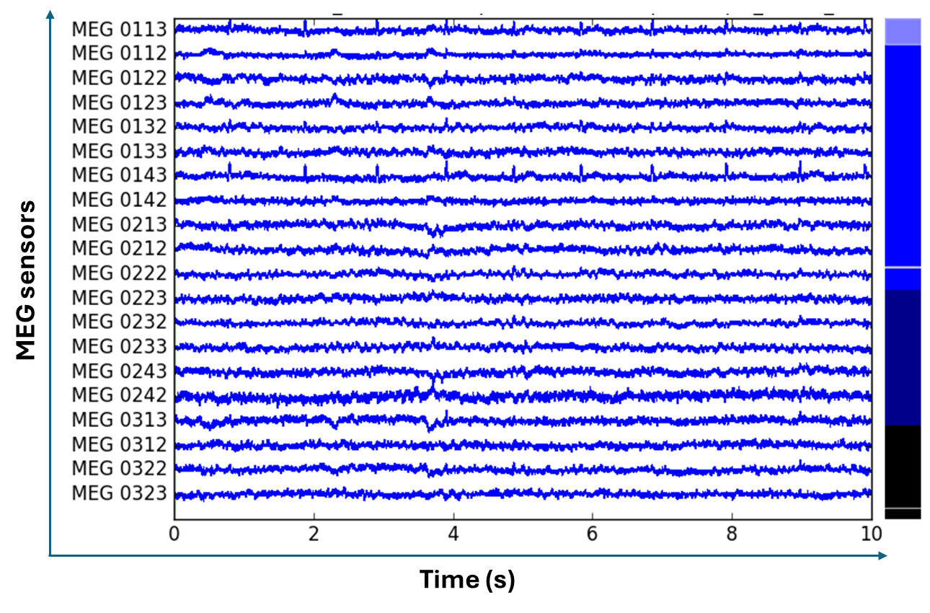
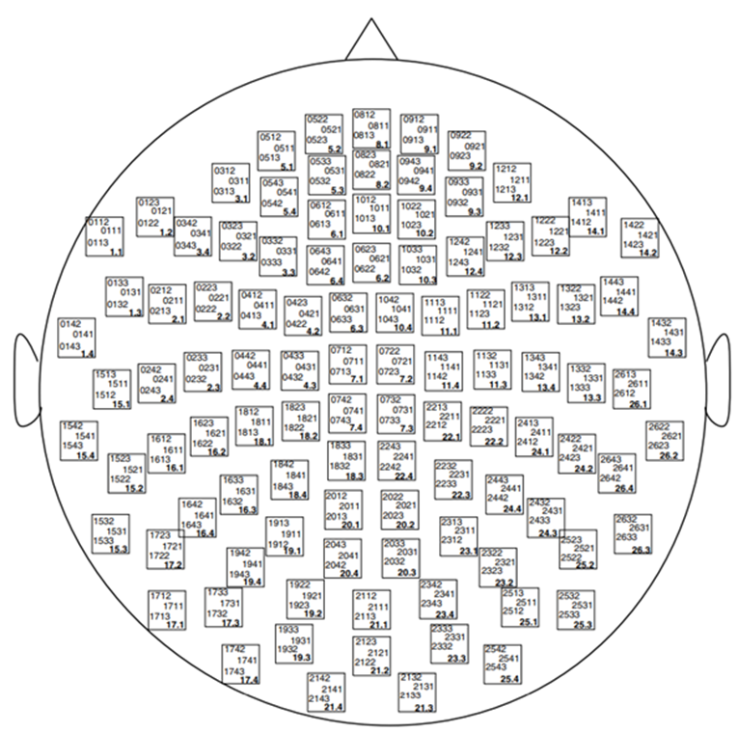
- Eye tracking data:
The raw data is a tuplet of x, and y coordinates and the pupil size of the eyes at each millisecond (1K sampling rate).
We parse the raw eye movements into different events, such as total reading time, gaze durations and saccade durations for a given word; and the fixation sequence for a given sentence, the so-called scan path.
- Total reading time: the total amount of time a reader spends looking at a word, including multiple visits and regressions, indicating the overall processing of the word.
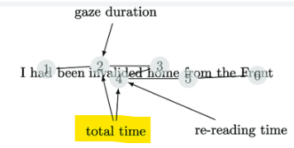

Literature review:
Using eye movement patterns to improve LLMs:
- Improving Natural Language Processing Tasks with Human Gaze-Guided Neural Attention
- Using human gaze data to guide the neural attention in LLMs
- Fine-Tuning Pre-Trained Language Models with Gaze Supervision
- Using scan path data to fine-tune LLMs

Comparing activations in LLMs & the brain
- Brains and algorithms partially converge in natural language processing
- This study also involves MEG data, we can learn from it how to deal with time-series data when compared to non-temporal activations in LLM
- Shared functional specialization in transformer-based language models and the human brain
- fMRI data
- Comparing different layers of the “embedding” and “transformation” module with activation in different brain regions

Weekly meetings & to-do list:
20250312
- Introducing the project to collaborators
- Decide on the research questions of the project
To do:
- draft a Google document for this project and share it with collaborators
- Figure out how to constrain LLM with eye movement data

20250326
- Walked through this document
- Talked about a potential simple project as a starting point: using eye-tracking data to adjust the parameters of top-k in the MoE architecture.
We haven’t figured out how to “add” the brain data yet due to their high dimension, it is hard to align with other features; also, the complexity of brain data makes it hard to just extract/compress the right amount of information.
Now the strategy is to first do a CS project (aiming for a CS conference): using eye tracking data to see whether it can improve the LLM’s performance; then, add on the brain data to conduct a cognitive neuroscience project (aiming for a cognitive neuroscience journal article)
To do:
- Prepare all the eye movement data into CSV files

